CompTIA NETWORK+ N10-009 Study Notes
This is our first installment of a new study guide for Network+. We will add a post for each CompTIA main domain and sub-objective.

Exam Main Domain 1.0: Networking Concepts

Exam sub-Objective 1.1: “Explain concepts related to the Open Systems Interconnection (OSI) reference model.”
The Open Systems Interconnection (OSI) reference model is one of the most important frameworks in the field of computer networking. It was developed by the International Organization for Standardization (ISO) in 1984 as a conceptual model to standardize the functions of a communication system without being tied to a specific technology. The OSI model divides the networking process into seven distinct layers, each of which performs a well-defined role in the transmission of data across networks. By segmenting the tasks, the model helps engineers, developers, and administrators understand complex interactions, troubleshoot issues, and design interoperable systems.
In this discussion, we will explain the concepts of the OSI model, examine the purpose of each of its seven layers, and highlight its practical importance in networking.

Purpose of the OSI Model
The OSI model was not intended to be implemented exactly as designed; rather, it serves as a guide to understand how networking components work together. Its goals can be summarized as follows:
- Standardization: The OSI model provides a common language for vendors, developers, and engineers, ensuring devices from different manufacturers can work together.
- Modularity: By breaking down communication into layers, each layer can be designed and updated independently.
- Interoperability: Systems built with OSI principles can interconnect more easily, even if they use different hardware or software technologies.
- Troubleshooting: Problems can be isolated by examining specific layers, making network management more efficient.

The Seven Layers of the OSI Model
The OSI model is composed of seven layers arranged in a hierarchy. Data moves down the layers when being transmitted and moves upward when being received. Each layer provides services to the layer above it and relies on the services of the layer below it.
1. Physical Layer
The Physical Layer is the lowest level of the OSI model. It defines the physical means of transmitting raw bits over a communication medium. This includes specifications for cables, connectors, voltage levels, modulation, and signal timing.
- Functions:
  - Transmission and reception of raw binary data (0s and 1s).
  - Definition of electrical, optical, or radio signals.
  - Handling of physical topology (bus, star, ring, mesh).
- Examples: Ethernet cables (Cat5, Cat6), fiber optic cables, hubs, repeaters, radio frequencies in Wi-Fi.
The physical layer does not interpret the meaning of bits; it only ensures they are transmitted.

2. Data Link Layer
The Data Link Layer is responsible for reliable transfer of data across a single physical link. It takes raw bits from the physical layer and organizes them into frames. It also adds error detection and correction mechanisms.
- Functions:
  - Framing: dividing the stream of bits into manageable chunks.
  - Error detection/correction using checksums or cyclic redundancy checks (CRC).
  - Flow control to prevent a fast sender from overwhelming a slow receiver.
  - Media Access Control (MAC), determining how multiple devices share the same physical medium.
- Examples: Ethernet (IEEE 802.3), Wi-Fi (IEEE 802.11), switches, bridges, PPP (Point-to-Point Protocol).
The data link layer is often divided into two sublayers:
- Logical Link Control (LLC): manages error checking and flow control.
- Media Access Control (MAC): manages access to the shared medium.

3. Network Layer
The Network Layer handles logical addressing and routing, enabling data to travel across multiple links and networks. Its key responsibility is to determine the best path for data packets from source to destination.
- Functions:
  - Logical addressing (IP addresses).
  - Routing: choosing optimal paths using routing tables and algorithms.
  - Packet forwarding between networks.
  - Fragmentation and reassembly of large packets to fit into smaller frames.
- Examples: Internet Protocol (IPv4, IPv6), routers, ICMP (Internet Control Message Protocol), OSPF, BGP.
Without the network layer, communication would be limited to directly connected devices only.

4. Transport Layer
The Transport Layer ensures reliable delivery of data from one end system to another, regardless of how many networks are crossed. It provides error detection, correction, sequencing, and flow control at a higher level than the data link layer.
- Functions:
  - End-to-end connection establishment and termination.
  - Segmentation of data into smaller chunks for efficient transmission.
  - Error recovery through retransmissions.
  - Multiplexing of different applications onto the same network connection.
- Examples: Transmission Control Protocol (TCP), User Datagram Protocol (UDP).
TCP provides reliable, connection-oriented service, whereas UDP offers faster, connectionless communication with less overhead.

5. Session Layer
The Session Layer establishes, manages, and terminates sessions between two applications. A session represents a continuous exchange of data between devices, allowing synchronization and recovery if disruptions occur.
- Functions:
  - Session establishment, maintenance, and termination.
  - Synchronization points (checkpoints in long transmissions).
  - Dialog control (who can transmit data at a given time).
- Examples: Remote Procedure Call (RPC), NetBIOS, SQL session management.
Though many modern protocols embed session management into application or transport layers, the conceptual distinction is useful.

6. Presentation Layer
The Presentation Layer acts as a translator between the application layer and lower layers. It ensures data is in a usable format, handling syntax and semantics.
- Functions:
  - Data translation between different formats and encoding schemes.
  - Data compression to reduce transmission size.
  - Encryption and decryption for security.
- Examples: SSL/TLS, JPEG, MPEG, ASCII, EBCDIC.
Essentially, the presentation layer prepares data for the application and ensures that it can be understood regardless of system differences.

7. Application Layer
The Application Layer is the topmost layer, closest to the end user. It provides services and interfaces for applications to communicate over the network.
- Functions:
  - Offering network services directly to user applications.
  - Supporting functions like email, file transfer, web browsing, and remote login.
- Examples: HTTP, HTTPS, FTP, SMTP, DNS, SNMP.
The application layer should not be confused with applications themselves; rather, it provides the underlying protocols that applications use.
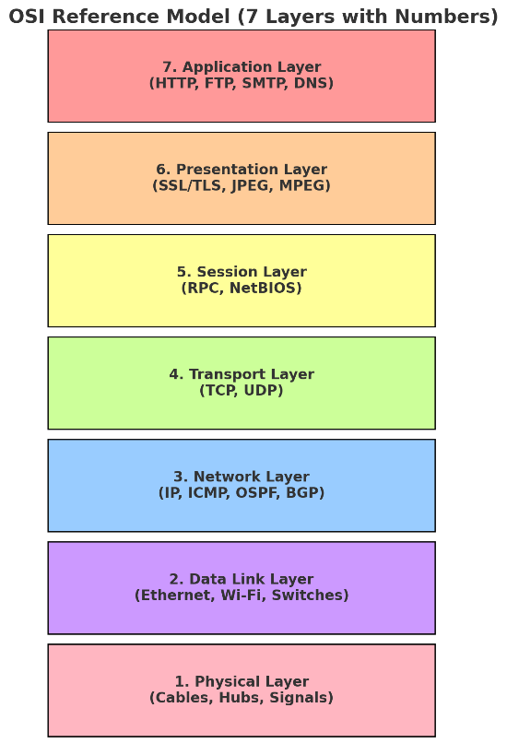

Encapsulation and Decapsulation
A fundamental concept in the OSI model is encapsulation. As data moves from the top (application) layer down to the physical layer, each layer adds its own header (and sometimes trailer) containing information needed for its functions. At the receiving end, the process of decapsulation occurs, where headers are removed layer by layer as the data moves up the stack.
This modular approach ensures that each layer performs a specific task without interfering with others, making networking more manageable and scalable.

Importance of the OSI Model
The OSI model remains vital in computer networking for several reasons:
- Educational Tool: It is widely used for teaching and understanding networking concepts.
- Troubleshooting: Network engineers can identify issues by isolating them at specific layers. For example, if a device receives signals but cannot access websites, the issue may be at the transport or application layer.
- Design and Development: Standards bodies and protocol developers use the OSI framework to guide the creation of interoperable systems.
- Vendor Neutrality: By adhering to OSI principles, devices and software from different vendors can communicate effectively.

OSI Model vs. TCP/IP Model
In practice, the OSI model is primarily a theoretical framework. Real-world networking follows the TCP/IP model, which has four layers: link, internet, transport, and application. TCP/IP protocols dominate modern networking, particularly the Internet. However, the OSI model is more detailed, offering a clearer conceptual separation of concerns.
For example:
- OSI’s application, presentation, and session layers are typically combined into TCP/IP’s application layer.
- OSI’s data link and physical layers are grouped into TCP/IP’s link layer.
Despite these differences, the OSI model remains an essential reference for understanding networking concepts.

OSI Model vs TCP/IP Model
OSI Layer (7 Layers) | Functions | Example Protocols/Technologies | TCP/IP Layer (4 Layers) | Example Protocols/Technologies
7. Application | User services like email, file transfer, web access | HTTP, FTP, SMTP, DNS | 4. Application | HTTP, FTP, SMTP, DNS
6. Presentation | Data translation, encryption, compression | SSL/TLS, JPEG, MPEG | (Merged into Application Layer) | SSL/TLS, MIME, JPEG
5. Session | Session management, dialog control | RPC, NetBIOS | (Merged into Application Layer) | RPC, SQL sessions
4. Transport | End-to-end delivery, reliability, segmentation | TCP, UDP | 3. Transport | TCP, UDP
3. Network | Logical addressing, routing, path determination | IP, ICMP, OSPF, BGP | 2. Internet | IP, ICMP, ARP, RIP
2. Data Link | Framing, MAC addressing, error detection | Ethernet, Wi-Fi, PPP | 1. Network Access (Link) | Ethernet, Wi-Fi, PPP
1. Physical | Transmission of raw bits, cables, signals | Cables, hubs, radio signals | (Part of Network Access) | Fiber optic, copper cables, wireless signals

🔹 Key Takeaways:
- OSI has 7 layers, TCP/IP has 4 layers.
- OSI separates Presentation and Session, but TCP/IP merges them into Application.
- OSI separates Physical and Data Link, but TCP/IP merges them into Network Access.

